Wacman is a 3D Platformer based on Pacman, but with a twist; you play one of the ghosts! The last one alive, in fact. You must gather pellets in a timeframe to advance to the next level in search of the ever elusive high score.

Wacman roams the halls of these levels too, and is constantly searching to destroy you for once and for all. If you can find a power pellet before he can, you can destroy him, and earn yourself a precious 1UP.

3d platformer tdd

wacman

wacman

3d platformer tdd

Environment/World

Player

Shooting

Enemies (AI)

Interactions

Screens

Game Flow

Non-Goals

Tools

Systems

Systems Diagram

Open Issues

Document Changelist

CONTENTS

Environment/World

Levels feature classic Pacman maps/mazes, with the difficulty progressing as the player completes each level. Difficulty multipliers will include Wacman’s speed and the number of environmental hazards present. Bullets will occasionally fire from any point on the X and Z axis.

Platforms will also be present, adding verticality. When a PowerUp pellet is picked up by either Wacman or the player, a new PowerUp pellet will spawn in a random location somewhere else on the map. If the player picks up a PowerUp, they are invincible and can destroy Wacman, gaining bonus points and giving them a limited window before Wacman respawns and begins hunting again.

UI

* 3D Heads Up Display that shows currently equipped weapon and have their own particle effects. Bar displaying how much damage has been taken. UI prompts for when a weapon (ammo) is picked up. UI indication of whether or not a player is carrying a particular weapon (player can only carry one of each weapon at a time). Bars on enemies displaying how much damage they have taken.
* Weapons:
  + Hamburger
    - Splash Damage
  + Ketchup
    - Point Damage
  + Mustard
    - Point Damage
  + Milkshake
    - Splash Damage
* Death Panel
  + High Score
  + Restart Button
  + Quit Button
* Win Panel
  + High Score
  + Restart Button
  + Quit Button

Player

Basic movement will be with the WASD keys on the computer. The controls will vary depending on the camera angle, of which there are three, all third person. One side view of the player, one top down centered above the player, and one shoulder camera. The player must gather all the pellets in the level within the time limit to progress to the next level. They have three lives maximum, and can earn lost lives back by destroying Wacman. Once the player loses their last life, it’s game over, their high score is recorded, and they must start over.

Enemies (Artificial Intelligence)

Wacman uses a Raycast to constantly track the player’s location and move towards them. As Wacman gets closer to the player, his Wacman speed increases. If Wacman collides with a PowerUp pellet, a clone Wacman is spawned for a limited time. If the player destroys Wacman, he respawns after a limited time.

Interactions

* Player Manager interacts with:
  + Player Controller
  + Level Manager
  + Enemy Manager
  + Score
  + Pick Ups
  + Bullet Trap
  + Enemy
* Player Controller interacts with:
  + Player Manager
  + Camera Controller
* Level Manager interacts with:
  + Player Manager
  + Enemy Manager
  + Load New Level
  + Main Menu
  + Pause Menu
  + Score
* Enemy Manager interacts with:
  + Level Manager
  + Player Manager
  + Bullet Trap
  + Player Win/Lose
  + Enemy
* Pick Ups interacts with:
  + Score
  + Player Manager
* Load New Level interacts with:
  + Enemy multiplier
  + Level Manager

Screens

* Main Menu
  + New Game Button
  + Controls Panel
  + Settings Panel
  + High Score Button
  + Quit Button
* Pause Menu
  + Restart Button
  + Controls
  + Settings
  + Quit Button
* Gameplay
  + Camera 1
  + Camera 2
  + Camera 3
* Player Lost
  + Death Panel
  + Restart Button
* Player Won
  + Win Panel
  + Next Level Button

Game Flow Diagram

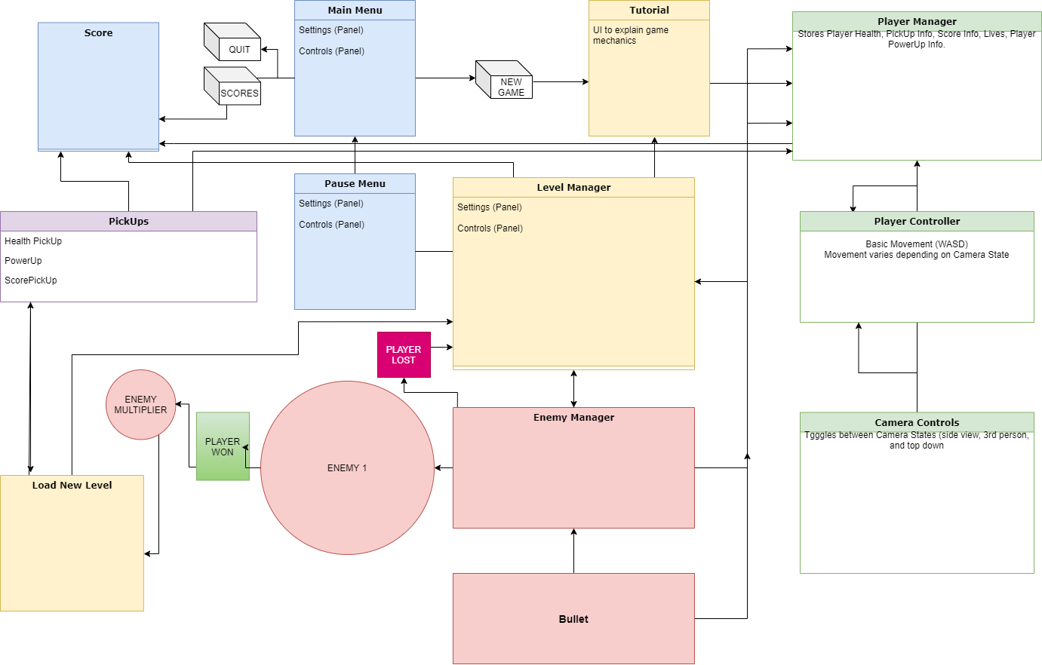

Non-Goals

* More audio (Sound FX/Music)
* High quality 3D modelling and lighting
* More Pick Ups (Fruit)
* Be able to save persistent high scores

Tools

**Unity 2020.1.5f1**

I’m at least somewhat proficient at using Unity, and starting to get more comfortable with C# and Unity offers a toolset large enough to expand game elements in the future (Cinemachine, Inkle, Different Inputs, Different Platforms, etc.)

**Visual Studio 2019**

Again what I’m familiar with using, and has various features that integrate with Unity and will be helpful for completing the project efficiently/

**DOTween**

DOTween will be used primarily to enhance the UI/UX of the game.

**Photoshop 2018**

Photoshop will be more than adequate for all basic and any additional UI/UX components.

Systems

* Pick Ups System
* Player Movement
* Enemy Player Tracking
* Bullet Trap Randomness
* Recording/Displaying Score and Stats
* UI
* Menus
* Scene Management

System Design Diagram

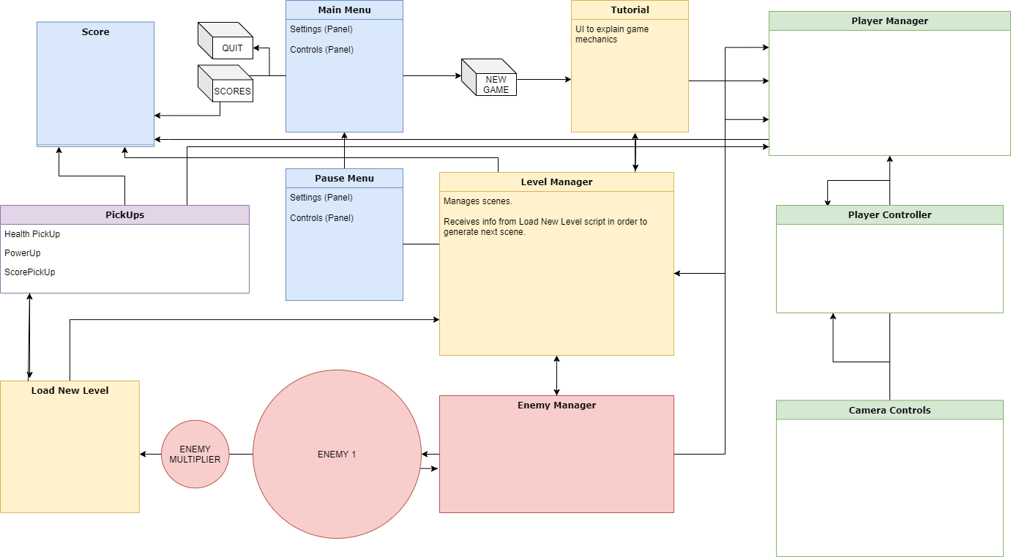

Open Issues

* + - Player Manager not tracking pickup pellets
    - Player PowerUp Bool not working (still killed by Wacman)

Document Changelist

|  |  |  |
| --- | --- | --- |
| Date | Name | Changes |
| 03/11/2020 | Tim | Document v1 |
|  |  |  |
|  |  |  |